

EpochEDU – Platform User Guide

GENERAL NOTES

* EpochEDU server can be run on a Plug Computer, on a Mac OS X laptop, on Solaris, on Linux, or even on Windows.
* The EpochEDU clients are on Android version 4.1-4.3, and rely on a modern web browser being available, either Firefox, Chrome, or “Browser”
* To achieve full capabilities, the EpochEDU MCPService must be running on each
* When tablet devices are idle for an extended period they may shut off their wifi or lose connection to the network.  In this case, you may need to reset the wifi by shutting it off and restarting it. (in wifi settings)

1.      Demo hardware Setup

* 1. SMILE Plug power on
  2. Plug IP address when connected to router is 10.1.0.1:5000
  3. Plug will automatically start services when it is plugged in.  Please allow  1 min it start up time prior to connecting wirelessly with devices

2.      Check tablet settings (same procedure for all tablets)

* 1. Use power button to turn on device
  2. Check WiFi settings to ensure Wifi is turned on (blue WiFi light on device should be lit)
  3. Ensure WiFi is on the proper network (SMILE-<MAC ADDR>)
     1. Settings  → Wireless Controls → Wifi indicates “connected to SMILE-<MAC ADDR>
     2. If not on SMILE-<MAC ADDR> select it from the list
  4. Ensure Block pup-up windows is NOT checked
     1. In browser touch the settings button → More → Settings → Block pup-up windows
  5. Ensure screen timeout is set to “NEVER”
     1. From home screen press Settings → Sound & display → scroll down to display settings → Screen Timeout → “Never Timeout”

GENERAL NOTES:  
Tablets vary in response times to screen touches.  Give them a second to respond when selecting something.

It is much better to use the stylus for interaction on the touchscreen than to use your finger

LOADING CONTENT VIA USB STICK

setup classroom folder(s) on USB stick

drop content into folder(s)

content of the <classname> folder will be displayed in that class. ( recommend using "demo")

navigate to

[http://10.1.0.1:5000/classmoderator/<classname>](http://192.168.1.16:5000/classmoderator/demo)

SD CARD IN TABLET

​to run local content (videos) files must be in the demo folder on the sd card

/sdcard/content/demo/<filename>

on student tablet

[http://10.1.0.1:5000/class/demo](http://192.168.1.16:5000/class/demo)

LANDING PAGE INTERFACE OVERVIEW:

Student /Teacher Landing Page:

You should see something similar (depends on screen size) to this when you login to the student landing page.  Home screen shortcut “Student” should get you to this page  ([http://10.1.0.1:5000/student](http://192.168.1.16:5000/student))

Home screen shortcut “Teacher” should get you to this page  ([http://10.1.0.1:5000/teacher](http://192.168.1.16:5000/teacher))

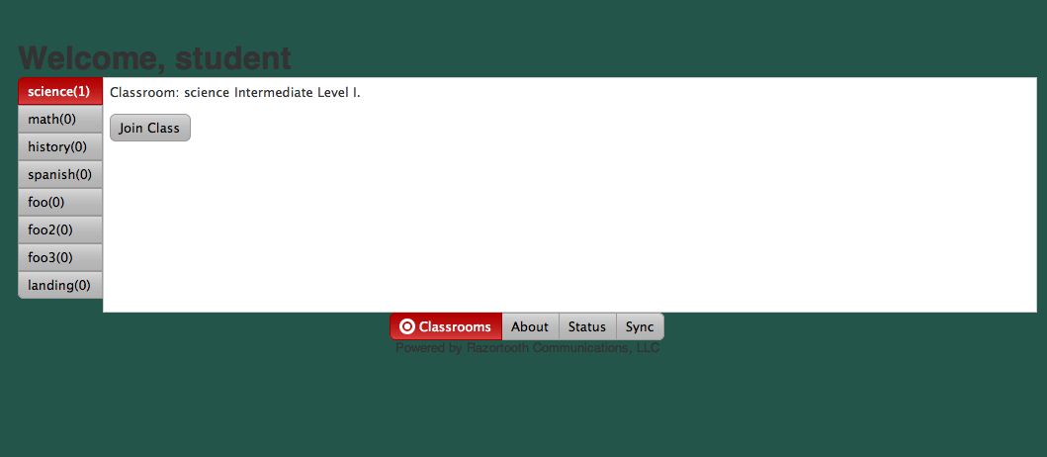

TEACHER INTERFACE OVERVIEW

**Classroom Name** **Start/Stop Button** **Logout**

**Session Data**

**Content Control (see below)**

**Chat input and send**

**List of all clients in session**

**Chat display area**

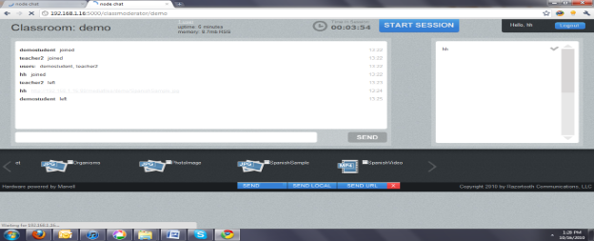

**Available Content Area (scroll left or right for more)**

**Content Select (checkboxes)**

**Content Control:**

**Send – Sends selected content to student (recommended to only send 1 at a time)  Once send button is pushed the checkmark will be cleared.**

**Send Local – Sends command to launch selected content on local device.  File must reside on local SD card for this to function properly.  This is intended to allow for large file sized (HD Videos) to be launched on the student devices without any concern for streaming them from the server.**

**Send URL – Sends a URL of the selected content via the chat interface so that students may launch the content from the server when they are ready to do this.**

**RED “X” (KILL) – Kills the local player on the student devices for any content that was sent to them (this does not work for content that was sent using the “Send Local” command)**

3.      START TEACHER SESSION

* 1. Point browser to teacher landing page
     1. Tap **Teacher** shortcut on home screen ([http://10.1.0.1:5000/teacher](http://192.168.1.16:5000/teacher))
     2. You should see something similar to this on your device…
  2. Click on “ Sciences Classroom”
  3. Login the teacher (suggestion: Teacher1) and click the “login now” button
     1. No password is required at this time

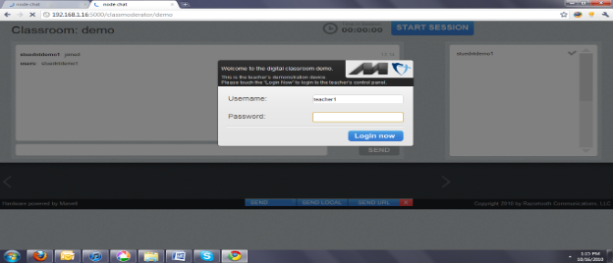

* + 1. You will see any students that have already logged in and your teacher name will also appear here
  1. Logged in Teacher view

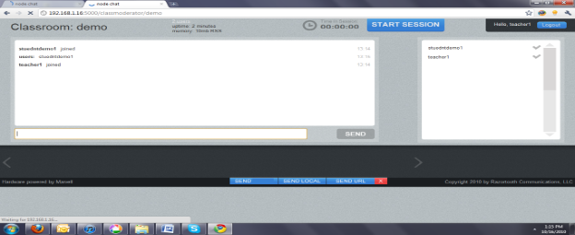

* + 1. You may use the CHAT window to send a chat message to students that are waiting to start the session (i.e. “Welcome, class will be starting in a few minutes”)
       1. They will not be able to respond until the session has started

4.      START STUDENT SESSION

* 1. Tap **Student** shortcut on Home Screen ([http://10.1.0.1:5000/student](http://192.168.10.1:5000/student))
     + 1. This will display the classrooms available
  2. Select  **Science**
     1. Login with a unique student name (no password required at this time)
     2. Tap Login now button

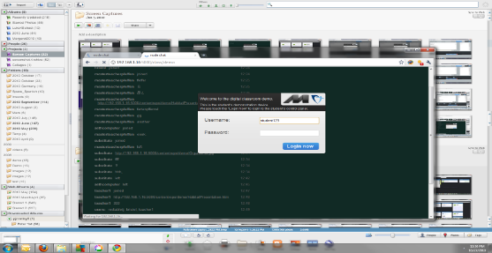

* + 1. Once logged in student tablet is locked until teacher initiates lesson
       1. Student can read any chat messages that are sent at this time

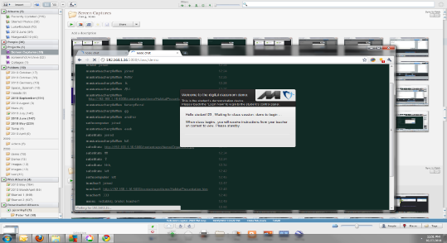

5.      Start Class Session on Teacher computer

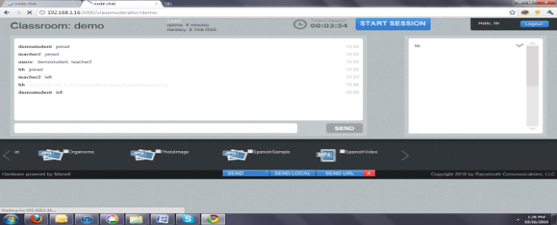

* 1. Click on the “Start MCP Mode” button in upper left of screen. This will cause student tablets to enter control mode. Once in control mode, the student cannot venture out to home screen to start games or do other tasks. The student will get sent to “EpochWatchdog” screen lock.
  2. Click on the “Stop MCP Mode” button in upper left of screen. This will disable control mode and free the student to perform other activities.
  3. Click on Start Session button to start teaching session
  4. Start session will change to “Stop Session” to indicate that session is active and the “time in session counter will begin counting

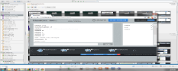

* 1. On Student devices the locked screen will change to an active screen

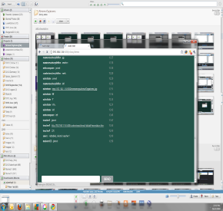

* 1. Now students can send messages if desired

6.      TEACHER SENDS CONTENT TO STUDENTS

* 1. Teacher initiates presentation
     1. Touch box next to content name to place a checkmark on desired content
     2. Click on “Send”

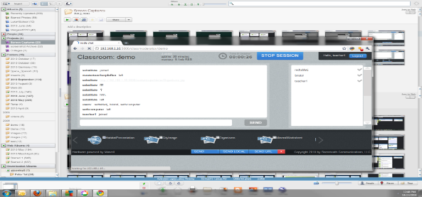

* + 1. This will initiate the presentation in a “lightbox” on the student and teacher devices

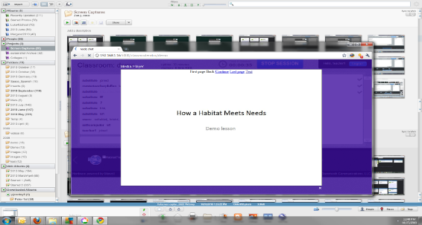

* + 1. Teacher can close lightbox by touching white “x” and presentation will continue to play on the student device

* + 1. Notice that the student interface is disabled while the presentation is playing
    2. For the demo, the presentation will step through each slide at 5 second intervals until it is completed.
    3. The last slide reads “Please read the Handouts…”
    4. When the presentation has concluded, the teacher should send a “kill” command to close the lightbox on the student devices

7.        
Other content to send to devices

* 1. Images
     1. Any items with JPG icon
  2. Video
     1. Any items with MP4 icon
     2. It works best to send this video by selecting it and then using the “Send Local” Command

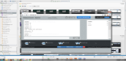

8.      **NOTE – Whenever content is opened using the “Send Local” or “Send URL” it will cause an additional window to be opened.  To close this window at the end of the video (or before) press the MENU button then tap windows and click to close the media window and return to student session or use the Back hard button to go back to the browser window**

“End” button on the bottom of the screen can be used by selecting a content, clicking “End”. This will send an “End” player event and cause the content displayed to go away.

9.      Teacher ENDS session by touching the “Stop Session” button



* 1. This will lock students’ devices again and end the lesson.

END OF DEMO SHUTDOWN SUGGESTIONS

1. Power down the tablets by holding down the power button and selecting power off and confirm message to shut down
2. Plug all tablets back into power so they can be used again for the next demo.
3. Turn off plug computer.

For technical or troubleshooting questions please contact Razortooth Communications:  - [dkords@razortooth.biz](mailto:dkords@razortooth.biz) – 415 644-8938 – dkords (skype)